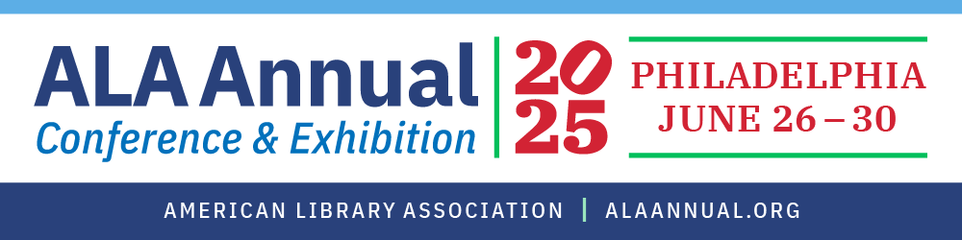

MAKING YOUR CASE TO ATTEND THE
2025 ALA ANNUAL CONFERENCE & EXHIBITION
Gaining approval for time off and travel and expense support for a conference depends on clearly demonstrating its value to your institution, manager, and colleagues. Communicating these benefits effectively is especially important when budgets are tight and staffing is limited.

Use this sample memo to help make your case.

Sample memo to your boss explaining why your attendance is a good investment.

To: Your Manager
From: You
Re: Attendance at the 2025 ALA Annual Conference & Exhibition
Date: As early as possible

ALA is excited to host library professionals at the ALA Annual Conference & Exhibition in Philadelphia, June 26-30, 2025. The conference delivers practical education, equipping library professionals with real-world solutions and strategies they can immediately implement. Attendees will gain insights from industry thought leaders and inspiring celebrity authors. In the Library Marketplace, we can connect with 650+ exhibitors, discover upcoming titles from top authors, explore cutting-edge multimedia resources, and engage in dynamic events, including Meet the Authors and more.
If I am supported in attending the 2025 ALA Annual Conference, here are ways that I will ensure that the investment pays dividends for the library and how I will make the most of the professional development opportunities.
[If you are a committee member or participate in ALA activities, list related meetings you plan to attend and why and how your participation can help the profession, your library, and your own professional development.]
[The following are suggested ways to talk about how you would spend your time.]
I will attend various education sessions and programs, among others:
List 4-5 programs related to your work and why they will help you do your job better.
- Program 1
- Program 2
- Program 3
- Program 4
I plan to spend adequate time in the Library Marketplace meeting with our current vendors and discovering new expert vendors in the areas of _________________. While meeting with vendors, I will search for new, cost-effective, and innovative products.
[List:]
- Current Vendors
- Vendors in a specific area/field
- New products you have read or heard about and those who may offer demos
I also look forward to the networking activities at the conference, as they will allow me to engage with peers and leaders who can offer ideas and new strategies. I will share my enthusiasm for my work and am excited to return home recharged with resources, new ideas, and a new focus on my role and career.
Following the steps below, I will ensure that what I learn benefits the library:
[Implement at least one new idea that can make your library more efficient and/or effective.]
- Share notes on sessions
- Share my list of action items and general ideas
- Provide a written report
I will need xx days away from work to attend. The costs are as follows:
[See Registration and Rates]
Thank you for your consideration.
[Name]

